# Port Technical Assessment - Revised Submission

## Question 1: JQ Patterns and JSON Transformation

### Overview

This exercise focuses on extracting specific information from Kubernetes deployment objects and Jira API responses using JQ patterns. JQ is a lightweight command-line JSON processor that allows for complex data extraction and transformation operations.

### Part A: Kubernetes Deployment Object Analysis

#### 1. Current Replica Count

**Pattern:** .status.readyReplicas **Output:** 1

**Explanation:** This pattern uses the dot operator (.) to navigate the JSON structure, starting from the root and accessing the status field, then the nested readyReplicas field. The status.readyReplicas field specifically tracks the number of replicas that are currently running and ready to serve traffic, which is crucial for monitoring deployment health.

#### 2. Deployment Strategy

**Pattern:** .spec.strategy.type **Output:** "RollingUpdate"

**Explanation:** This pattern navigates to the deployment specification (spec), then to the strategy configuration (strategy), and finally extracts the strategy type (type). The dot operator creates a path through the nested JSON structure: root → spec → strategy → type. This field determines how Kubernetes handles updates to the deployment.

#### 3. Service and Environment Labels Concatenation

**Pattern:** .metadata.labels.service + "-" + .metadata.labels.environment **Output:** "authorization-production-gcp-1"

**Explanation:** This pattern demonstrates JQ's string concatenation capabilities. It accesses the metadata section, navigates to the labels object, and extracts both the service and environment label values. The + operator concatenates these strings with a hyphen separator. The pattern follows this path: root → metadata → labels → service, combined with root → metadata → labels → environment.

#### Sample Kubernetes Deployment JSON Structure

{

"metadata": {

"labels": {

"service": "authorization",

"environment": "production-gcp-1"

}

},

"spec": {

"strategy": {

"type": "RollingUpdate"

}

},

"status": {

"readyReplicas": 1

}

}

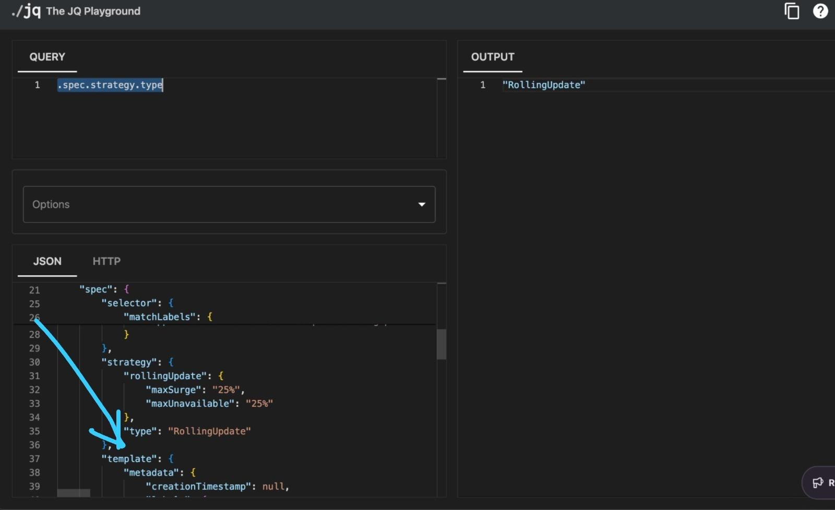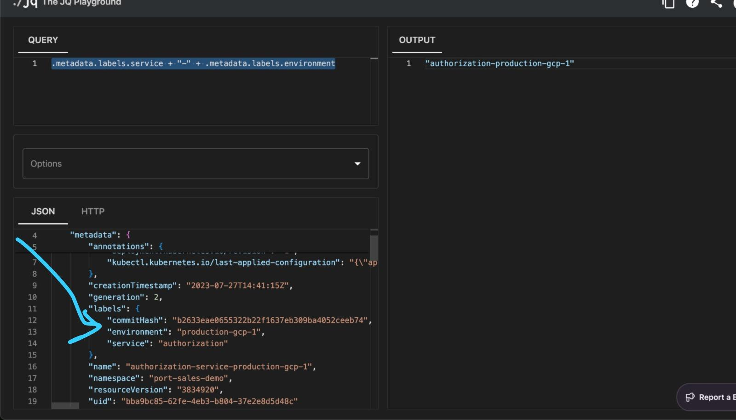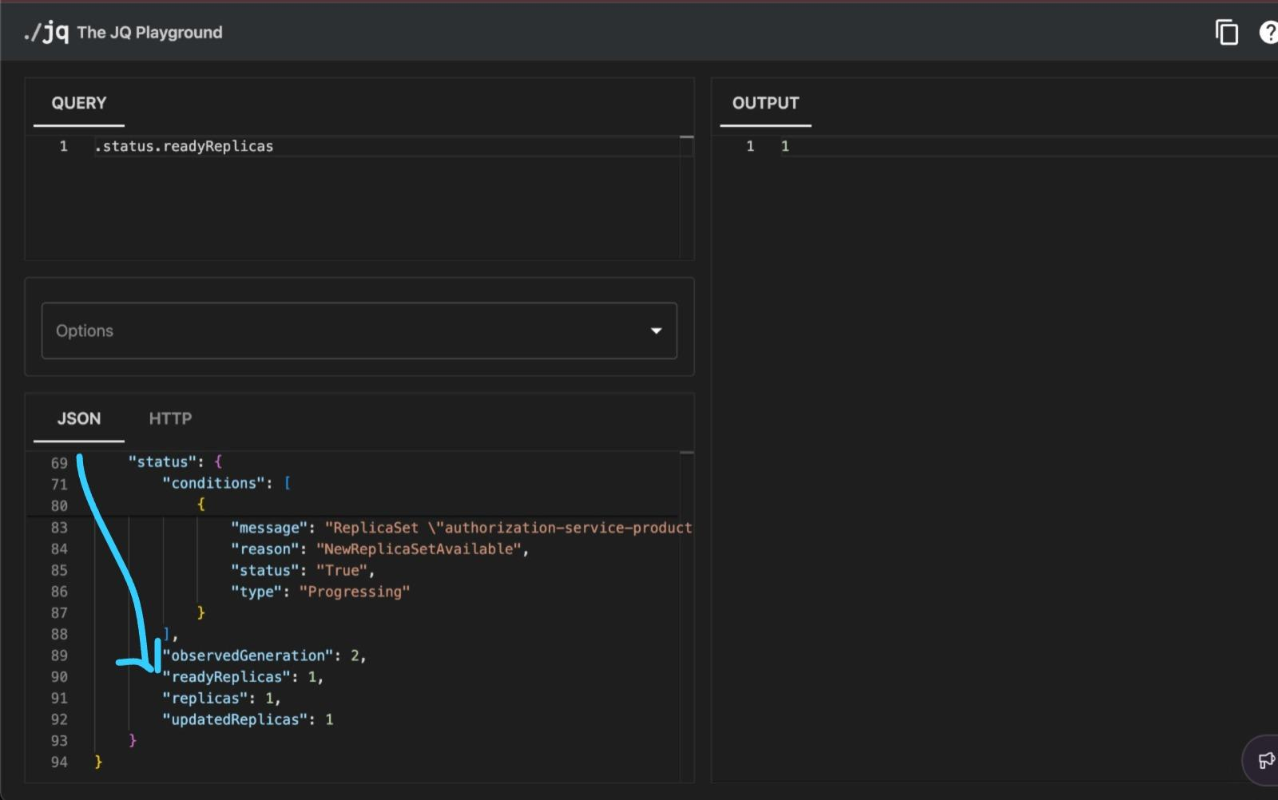

### Part B: Jira API Subtasks Extraction

#### Pattern for Extracting Subtask Keys

**Pattern:** [.fields.subtasks[].key] **Output:**

[

"SAMPLE-3894",

"SAMPLE-3895",

"SAMPLE-3896",

"SAMPLE-3897",

"SAMPLE-3898",

"SAMPLE-3899",

"SAMPLE-3900",

"SAMPLE-3902",

"SAMPLE-3904",

"SAMPLE-3901",

"SAMPLE-3905",

"SAMPLE-3906",

"SAMPLE-3907"

]

**Explanation:** This pattern combines several JQ features:

* **Array Construction:** The outer brackets [] create a new array from the extracted values
* **Array Navigation:** .fields.subtasks[] navigates to the subtasks array and iterates through each element using the empty brackets []
* **Field Extraction:** .key extracts the key field from each subtask object
* **Path Traversal:** The complete path is root → fields → subtasks → [each element] → key

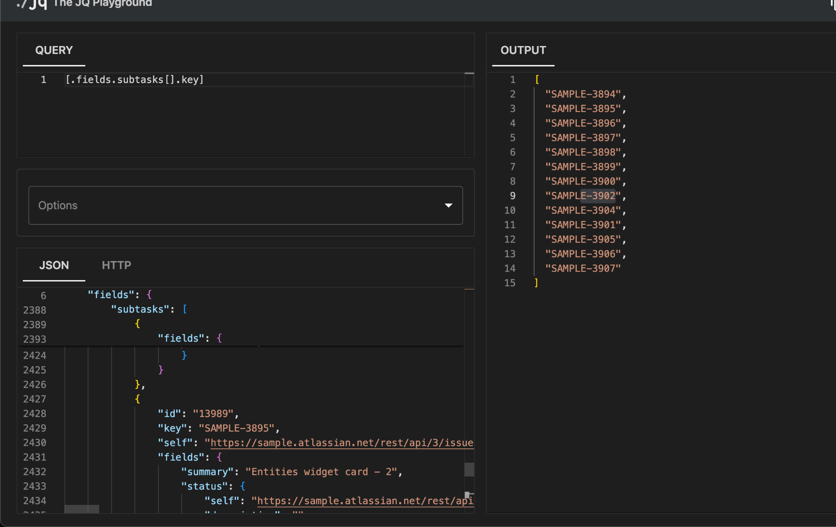

## Question 2: Port and Jira Integration Setup

### Overview

This exercise involves integrating Port with GitHub and Jira to create a comprehensive development workflow tracking system. The integration enables automatic synchronization of repositories, issues, and their relationships.

### Step 1: Port GitHub App Installation

#### Actions Performed

1. **Accessed GitHub App Installation**
   * Navigated to the Port GitHub App installation page
   * Selected the correct GitHub organization from the dropdown
   * **Important:** Granted access to specific target repositories rather than selecting "all repositories" for security best practices
2. **Permission Configuration**
   * Ensured the following critical permissions were granted:
     + **Actions: Read and Write** - Required for triggering and monitoring GitHub workflows
     + **Contents: Read** - Required for accessing repository content
     + **Metadata: Read** - Required for basic repository information
     + **Pull Requests: Read** - Required for PR tracking functionality

**Installation Verification** # Verification commands used

curl -H "Authorization: token <PAT>" \

<https://api.github.com/user/installations>

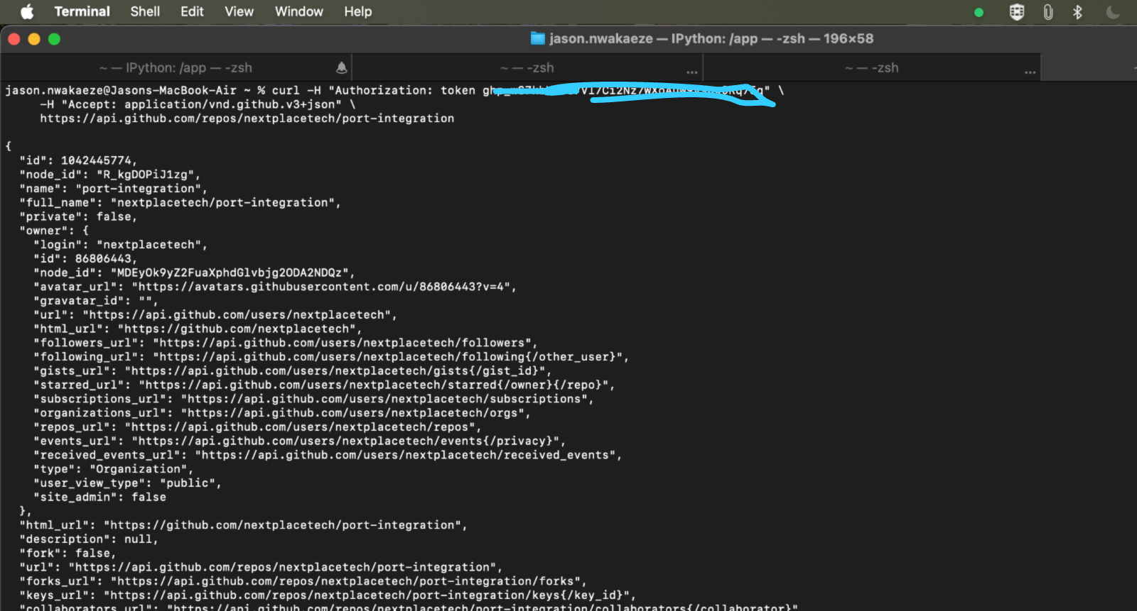

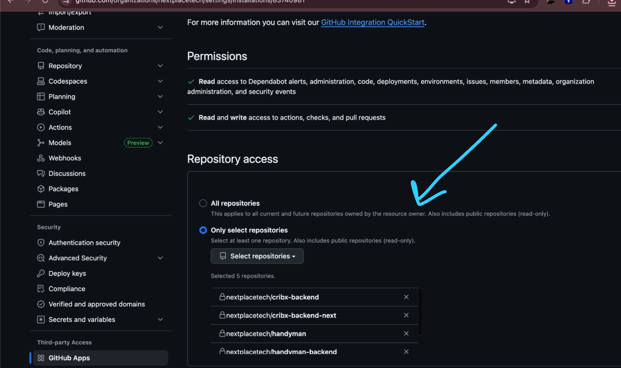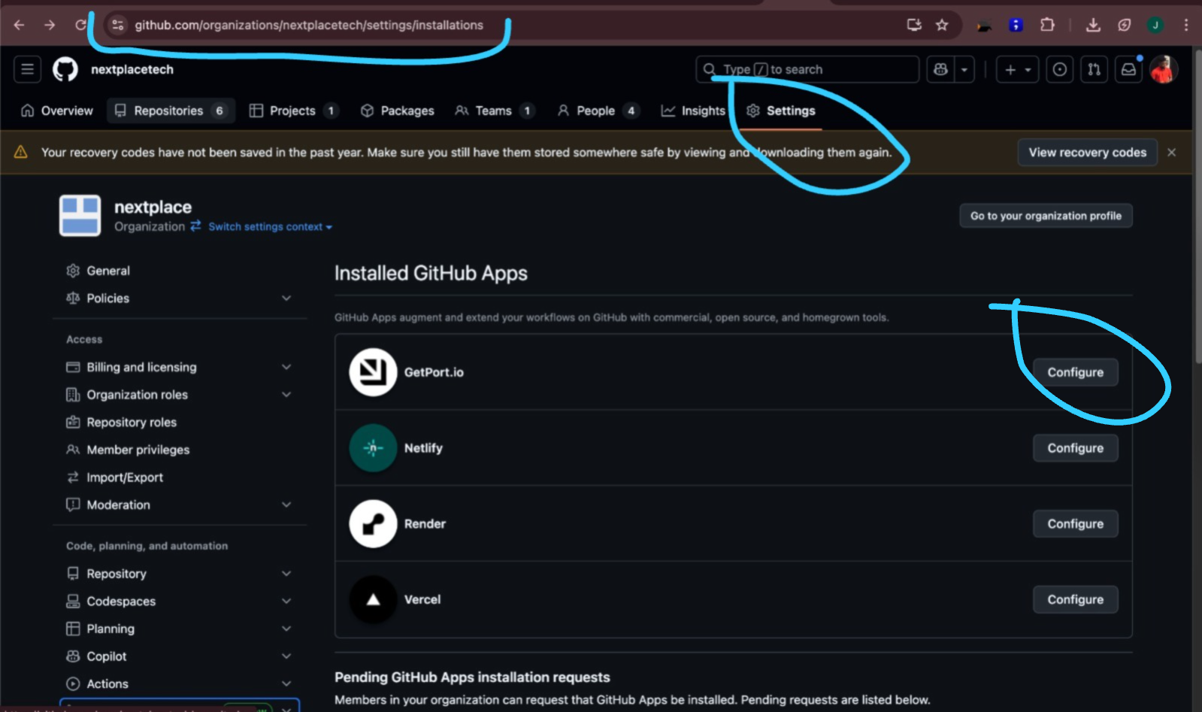

#### 

#### 

#### 

#### 

#### Verification Process

* **GitHub Side:** Navigated to Settings → Applications → Installed GitHub Apps to confirm "Port" appeared with selected repositories
* **Port Side:** Accessed Data Sources section in Port dashboard to verify repository synchronization
* **Repository Sync Status:** Confirmed all target repositories appeared in Port's Entities view

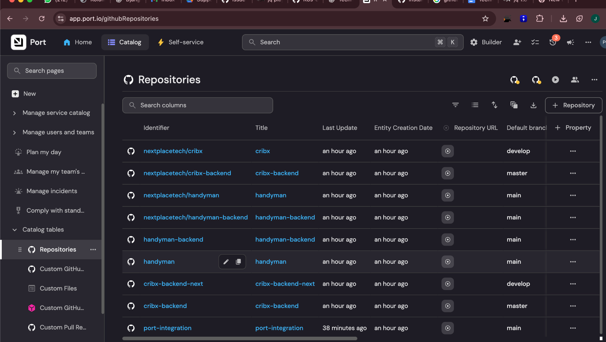

### 

### 

### 

### 

### 

### 

### 

### 

### Step 2: Jira Project Creation

#### Actions Performed

1. **Project Template Selection**
   * Accessed Jira Cloud dashboard
   * Selected: Projects → Create project → Software development → Scrum template
   * **Critical Selection:** Chose "Company-managed project" (not Team-managed) to access Components feature

**Project Configuration** Project Name: Port Integration Demo

Project Key: PID

Project Type: Company-managed

Template: Scrum

#### Verification Process

* **Company-managed Confirmation:** Project sidebar displayed company-managed specific settings
* **Components Access:** Confirmed Components option

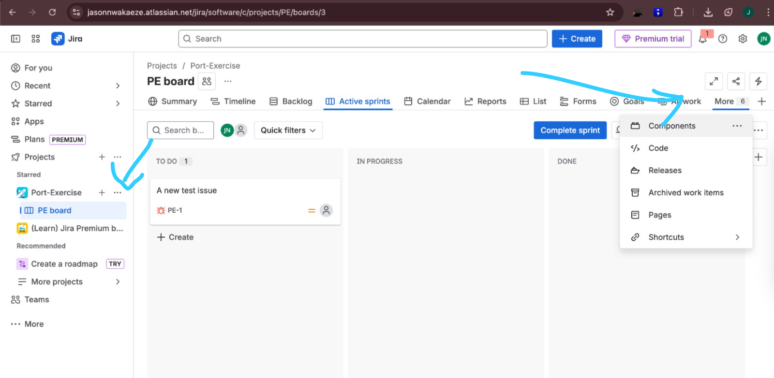

### 

### Step 3: Jira Components Creation

#### Actions Performed

Created Jira components to map to GitHub repositories:

1. **Component Creation Process**
   * Navigated to Project settings → Components → Create component
   * Created the following components:

Component 1:

Name: cribx-backend

Description: Backend services for Cribx application

Lead: <project-lead-email>

Component 2:

Name: handyman-frontend

Description: Frontend application for Handyman service

Lead: <project-lead-email>

#### Verification Process

* **Components List:** Verified components appeared in project Components section
* **Issue Assignment:** Created test issues and confirmed components could be assigned
* **Component Mapping:** Verified component names exactly matched corresponding GitHub repository names

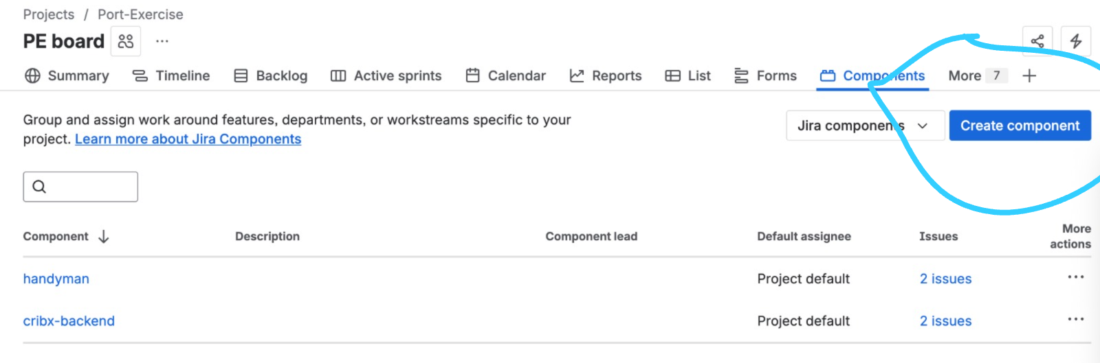

### Step 4: Port Jira Integration Deployment

#### Actions Performed

1. **Integration Configuration**
   * Accessed Port dashboard → Data Sources → Add Data Source → Jira
   * Selected **"Scheduled"** sync mode for regular updates
   * Chose **"GitHub Workflow"** as deployment method for CI/CD integration

**Authentication Setup** Generated Jira API credentials with required permissions:  
  
 Atlassian API Token Permissions:

- Read project permissions

- Read issue permissions

- Read component permissions

- Read user permissions

**GitHub Secrets Configuration** Added the following repository secrets in GitHub:  
  
 # Repository: Settings → Secrets and variables → Actions

PORT_CLIENT_ID=port_client_id_value

PORT_CLIENT_SECRET=port_client_secret_value

atlassianUserEmail=user@company.com

atlassianUserToken=generated_api_token

**Workflow Implementation** Created .github/workflows/jira-integration.yaml:  
  
 name: Jira Integration

on:

schedule:

- cron: '0 */1 * * *' # Every hour

workflow_dispatch:

jobs:

sync-jira:

runs-on: ubuntu-latest

steps:

- name: Sync Jira Data

uses: port-labs/ocean-jira-integration@v1

with:

portClientId: ${{ secrets.PORT_CLIENT_ID }}

portClientSecret: ${{ secrets.PORT_CLIENT_SECRET }}

atlassianUserEmail: ${{ secrets.atlassianUserEmail }}

atlassianUserToken: ${{ secrets.atlassianUserToken }}

jiraHost: https://company-domain.atlassian.net

1. 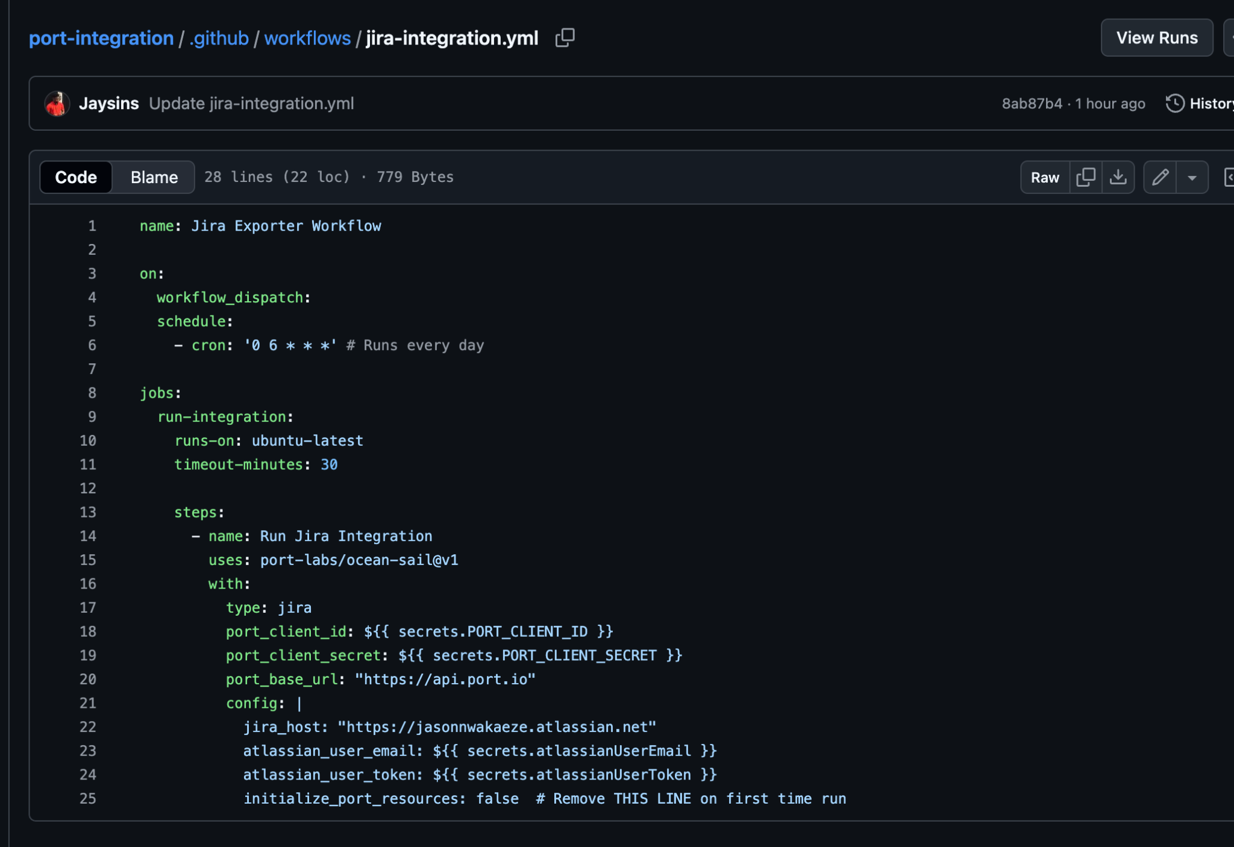

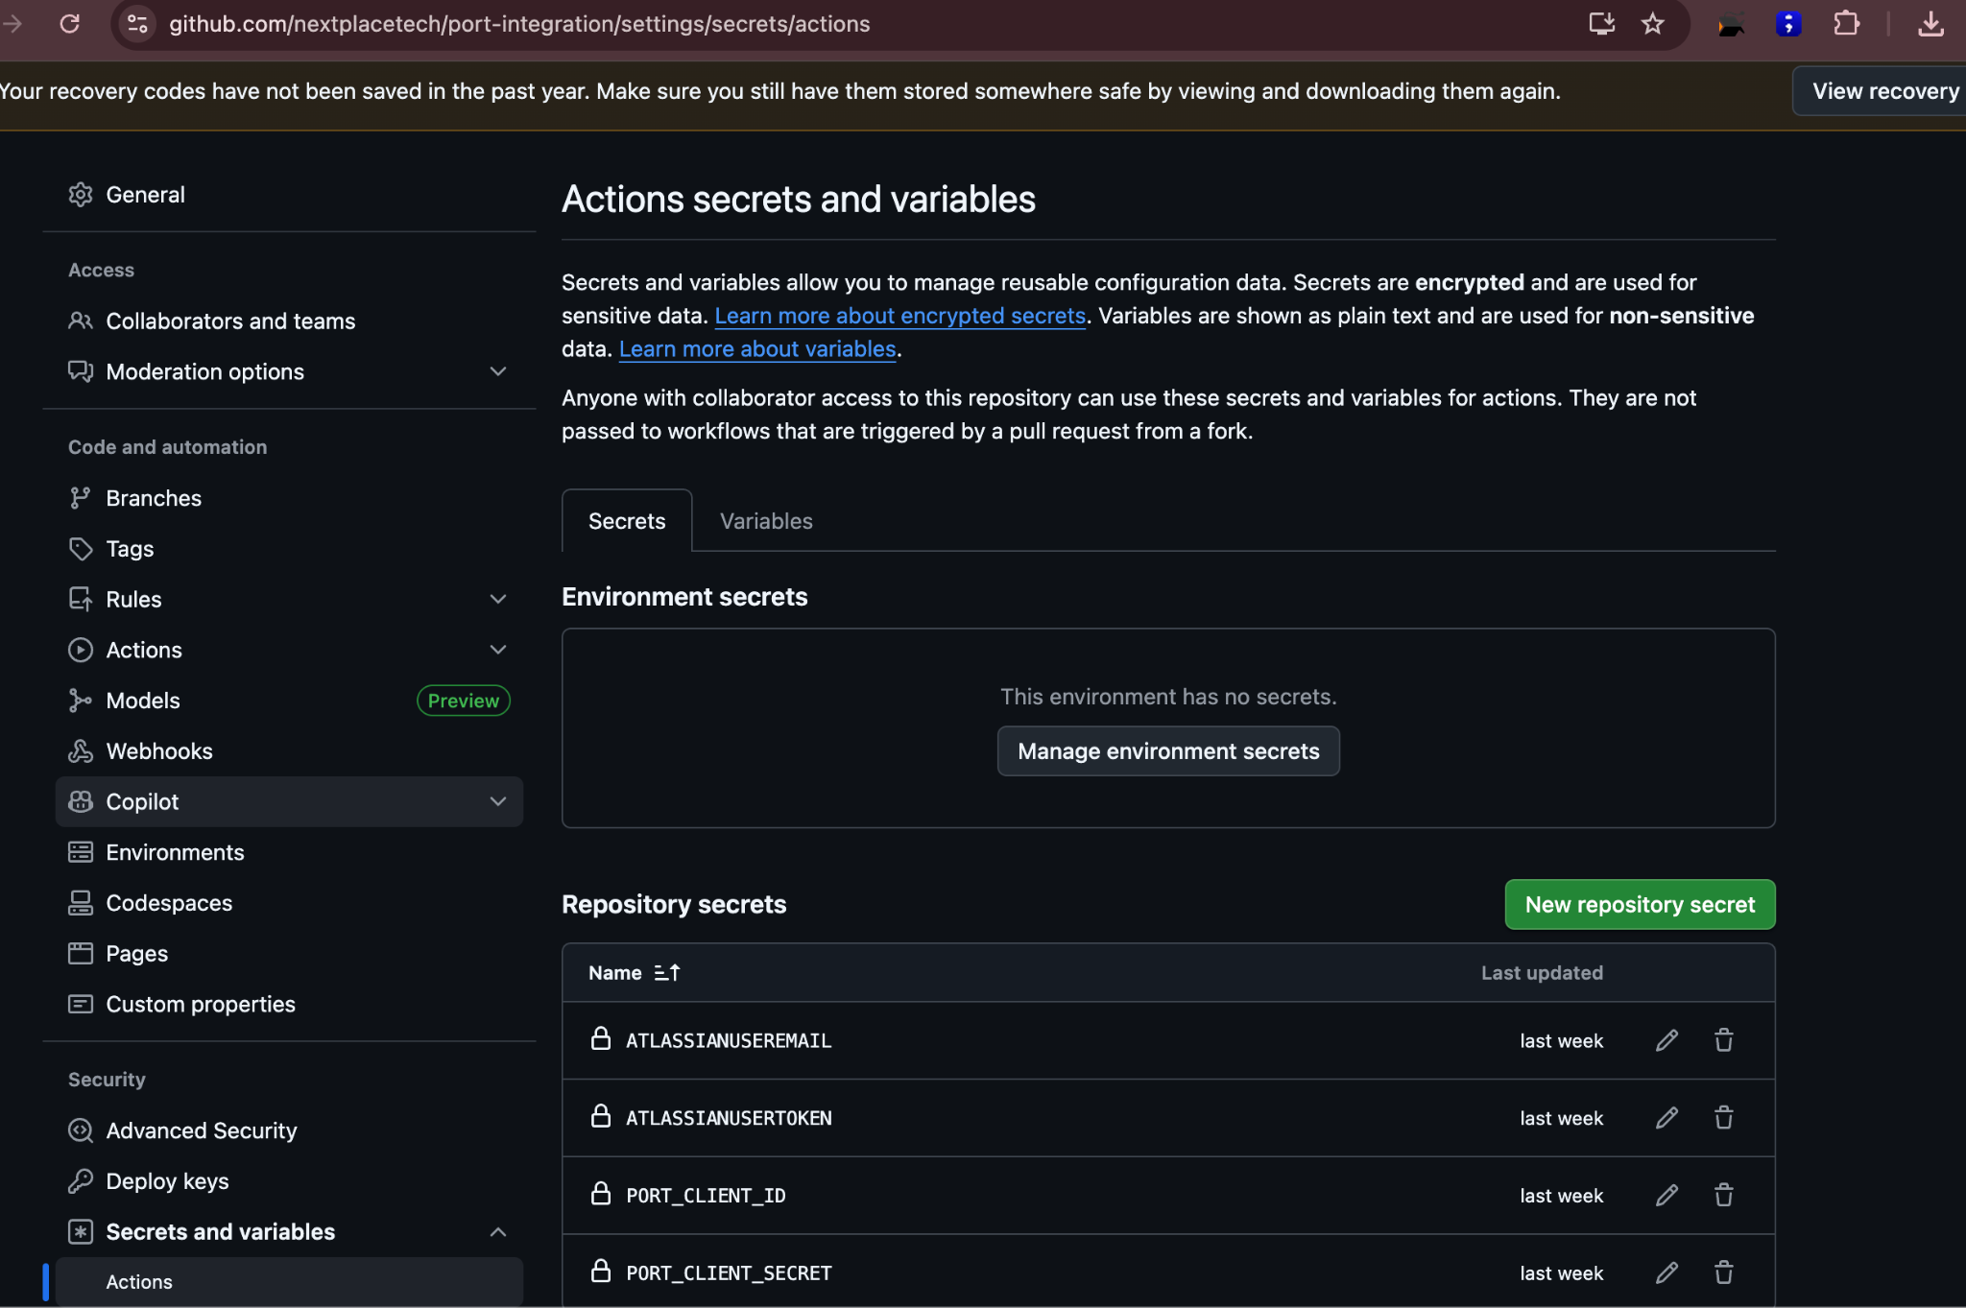

Verification Process

* **Manual Workflow Execution:** Triggered workflow using workflow_dispatch to verify immediate functionality
* **GitHub Actions Verification:** Confirmed successful execution in repository's Actions tab
* **Port Data Verification:** Observed synchronized Jira entities (projects, issues, components) in Port dashboard
* **Scheduled Execution:** Confirmed cron schedule (0 */1 * * *) triggered automatic hourly syncs

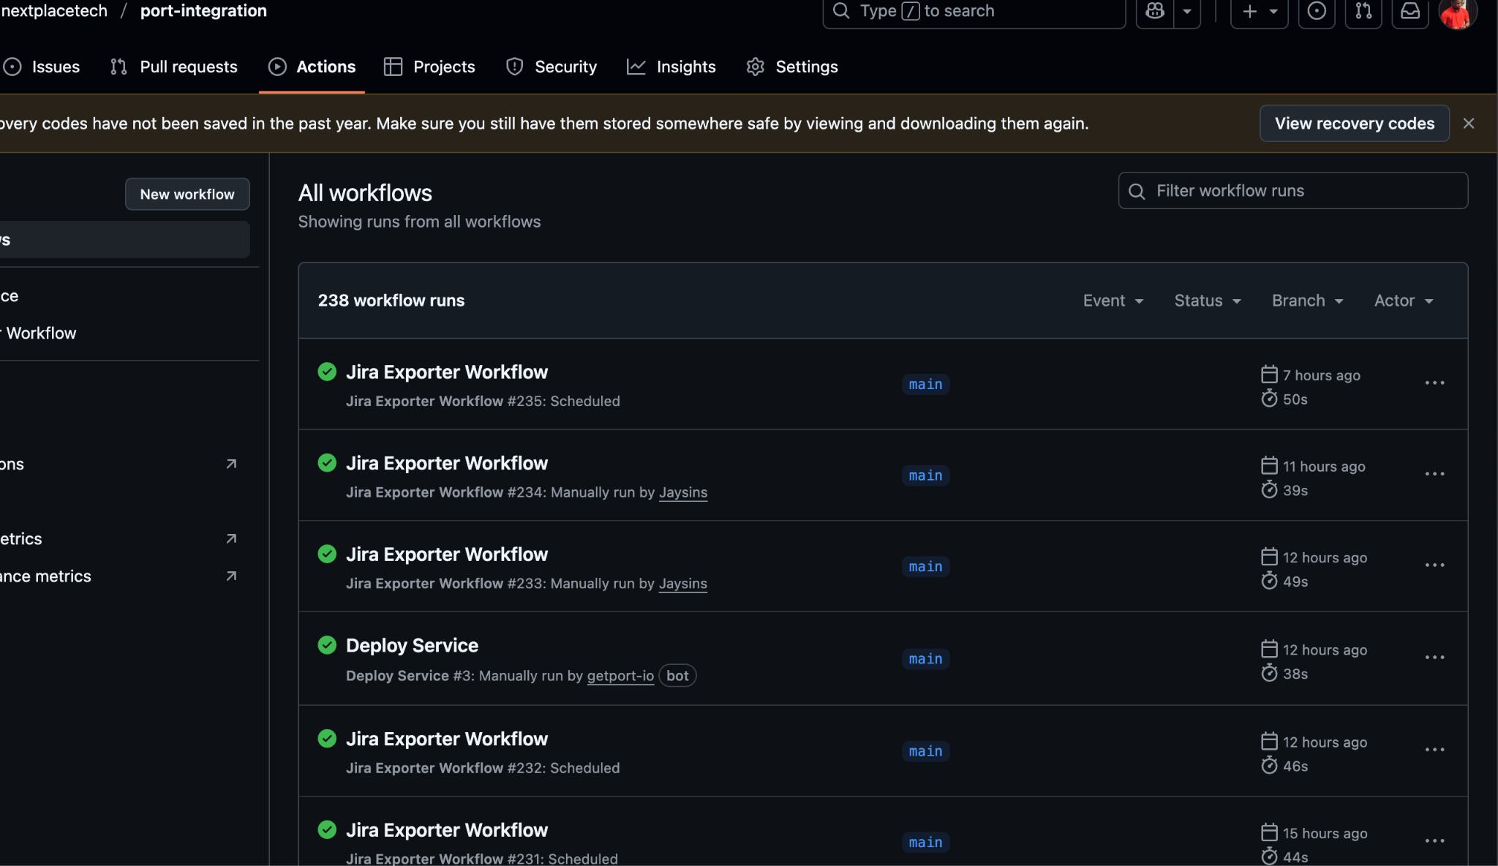

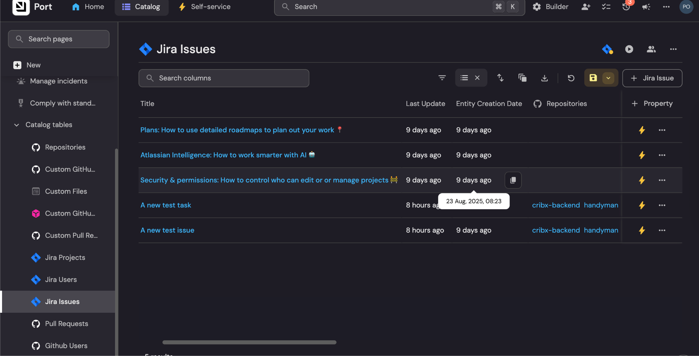

### Step 5: Jira Issue to Repository Relation

#### Actions Performed

1. **Blueprint Relation Configuration**
   * Accessed Port → Builder → Blueprints → Jira Issue blueprint
   * Added relation field to Repository blueprint:

{

"identifier": "repository",

"title": "Repository",

"target": "repository",

"many": true

}

**Mapping Logic Implementation** Updated Jira integration mapping to establish component-based relationships:  
  
 {

"resources": [

{

"kind": "issue",

"selector": {

"query": "project = PID"

},

"port": {

"entity": {

"mappings": {

"repository": ".fields.components[].name"

}

}

}

}

]

}

**Test Issue Creation** Created multiple test issues with different component assignments:  
  
 Issue PID-001: Assigned to cribx-backend component

Issue PID-002: Assigned to handyman-frontend component

Issue PID-003: Assigned to both components (multi-repository relation)

#### Verification Process

* **Relation Validation:** Confirmed Jira Issue entities in Port displayed populated Repository relations
* **Multi-Component Testing:** Verified issues assigned to multiple components correctly related to multiple repositories
* **Data Accuracy:** Cross-referenced Port relationship data with actual Jira component assignments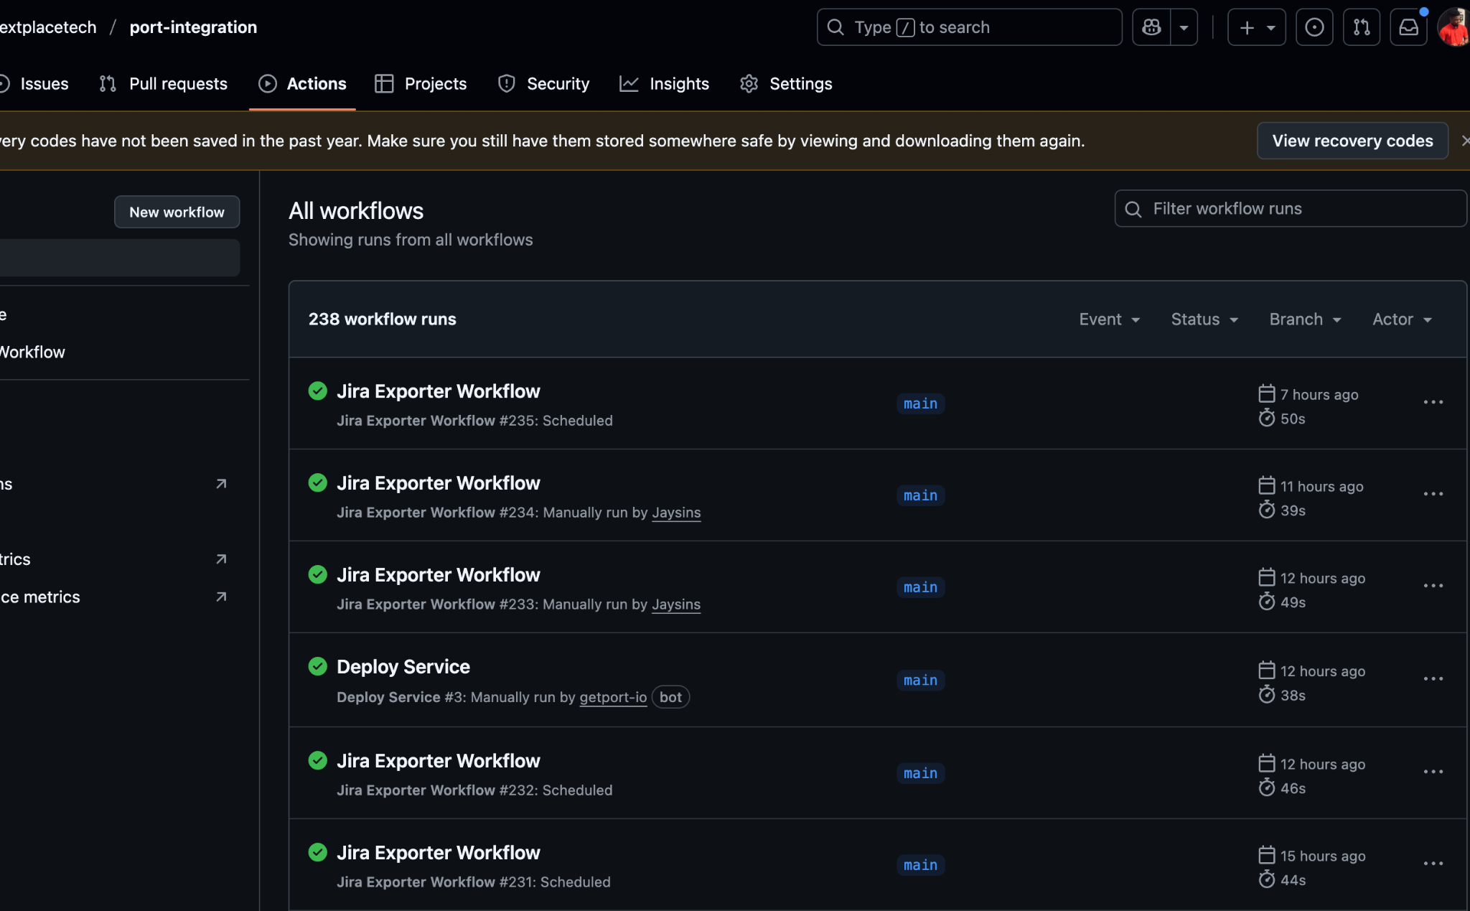

## Question 3: Repository Scorecard Implementation

### Overview

This exercise implements a dynamic scorecard system to evaluate repository health based on the number of open pull requests, providing automated quality assessment across multiple repositories.

### Step 1: Open PR Count Property Creation

#### Actions Performed

1. **Blueprint Property Addition**
   * Navigated to Port → Builder → Blueprints → Repository blueprint
   * Add new aggregation property with the following configuration:
   * Set title as Open Pull Requests
   * Select “Related blueprint” as Pull Requests
   * Set “Calculate by” as entities
   * Set “function” as “count”
   * Set Query filter to have “status” = “open”

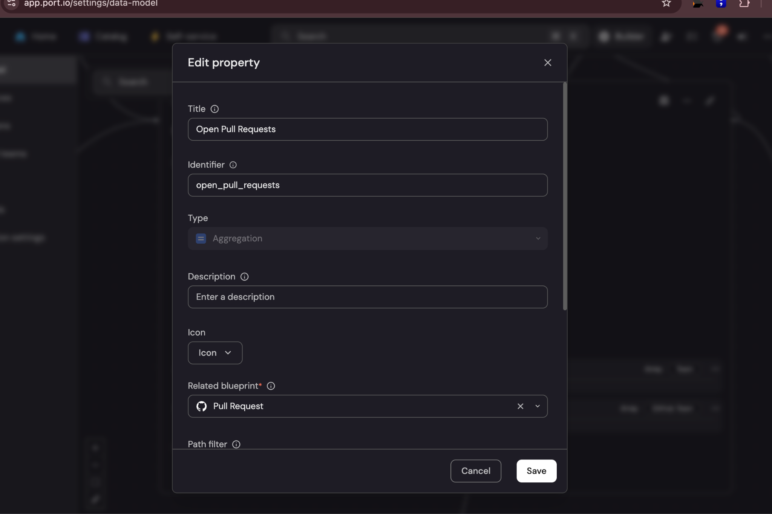

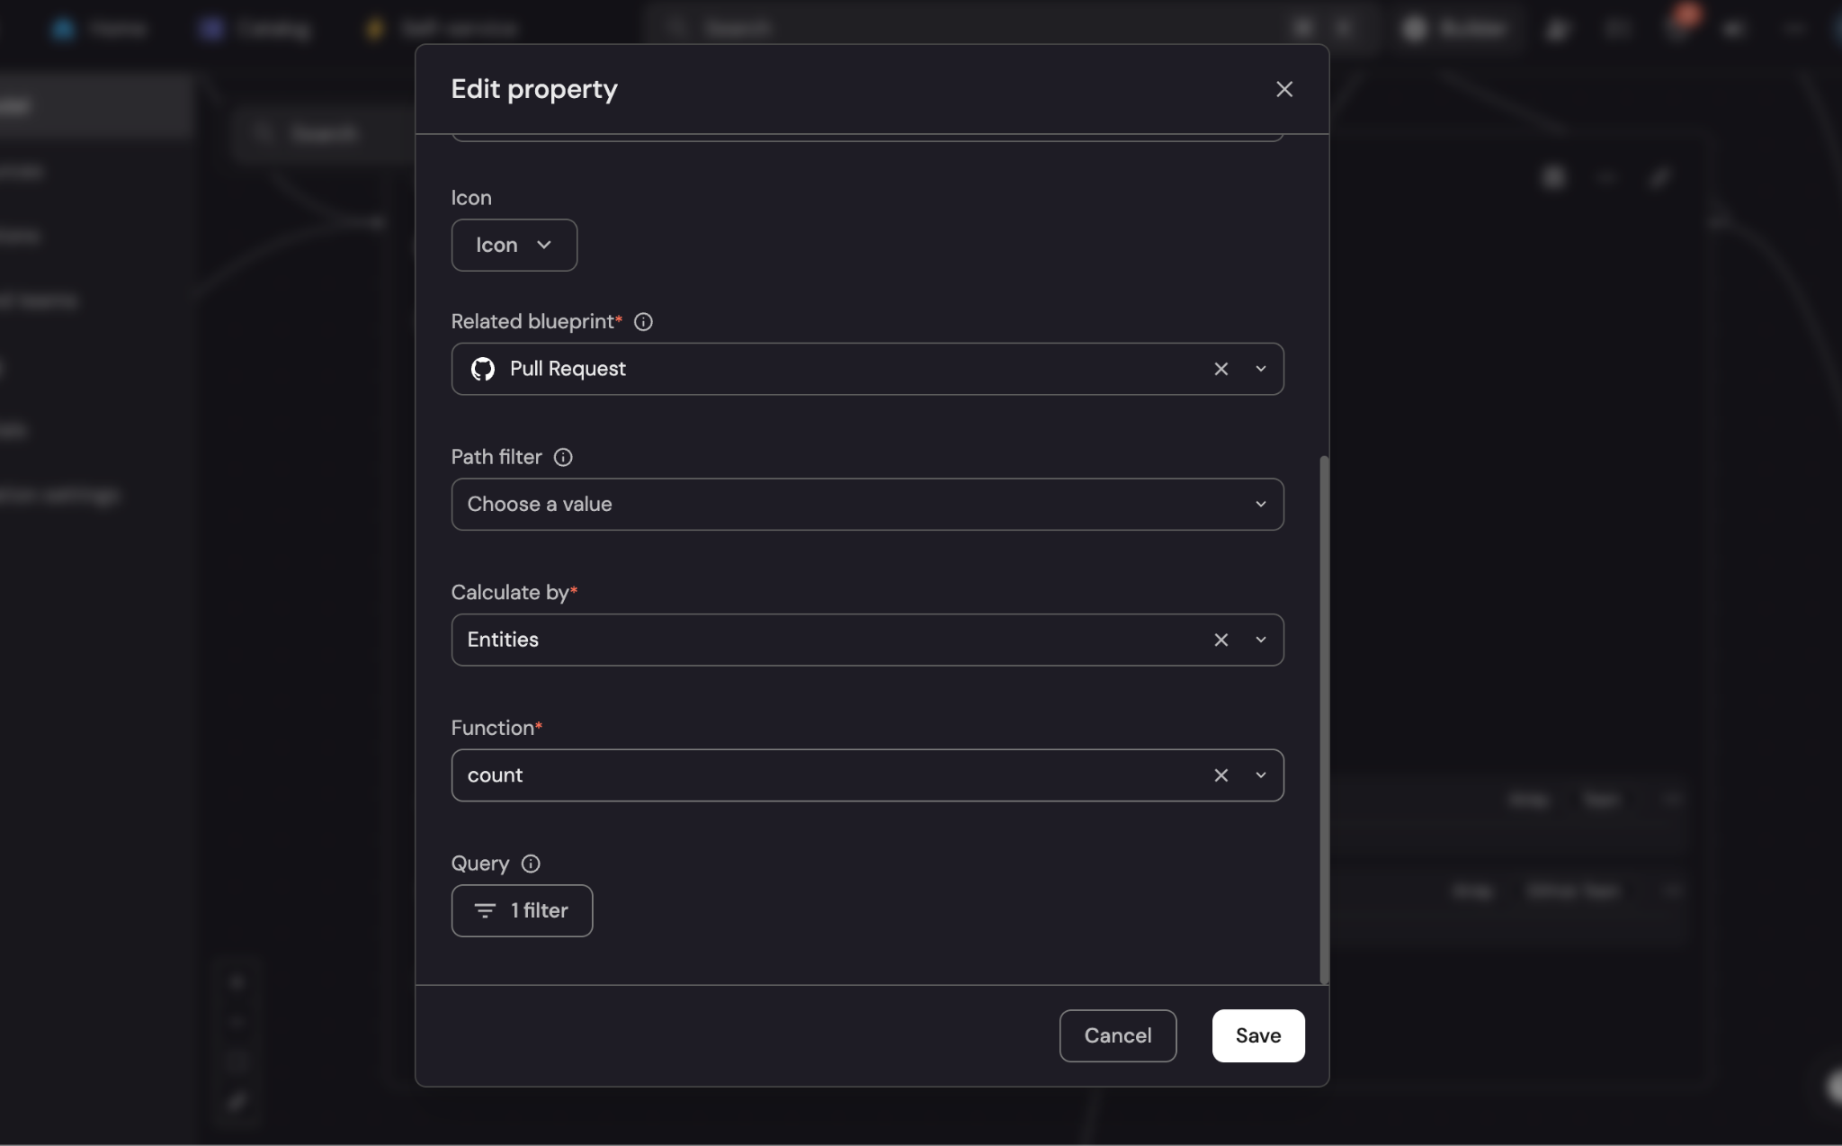

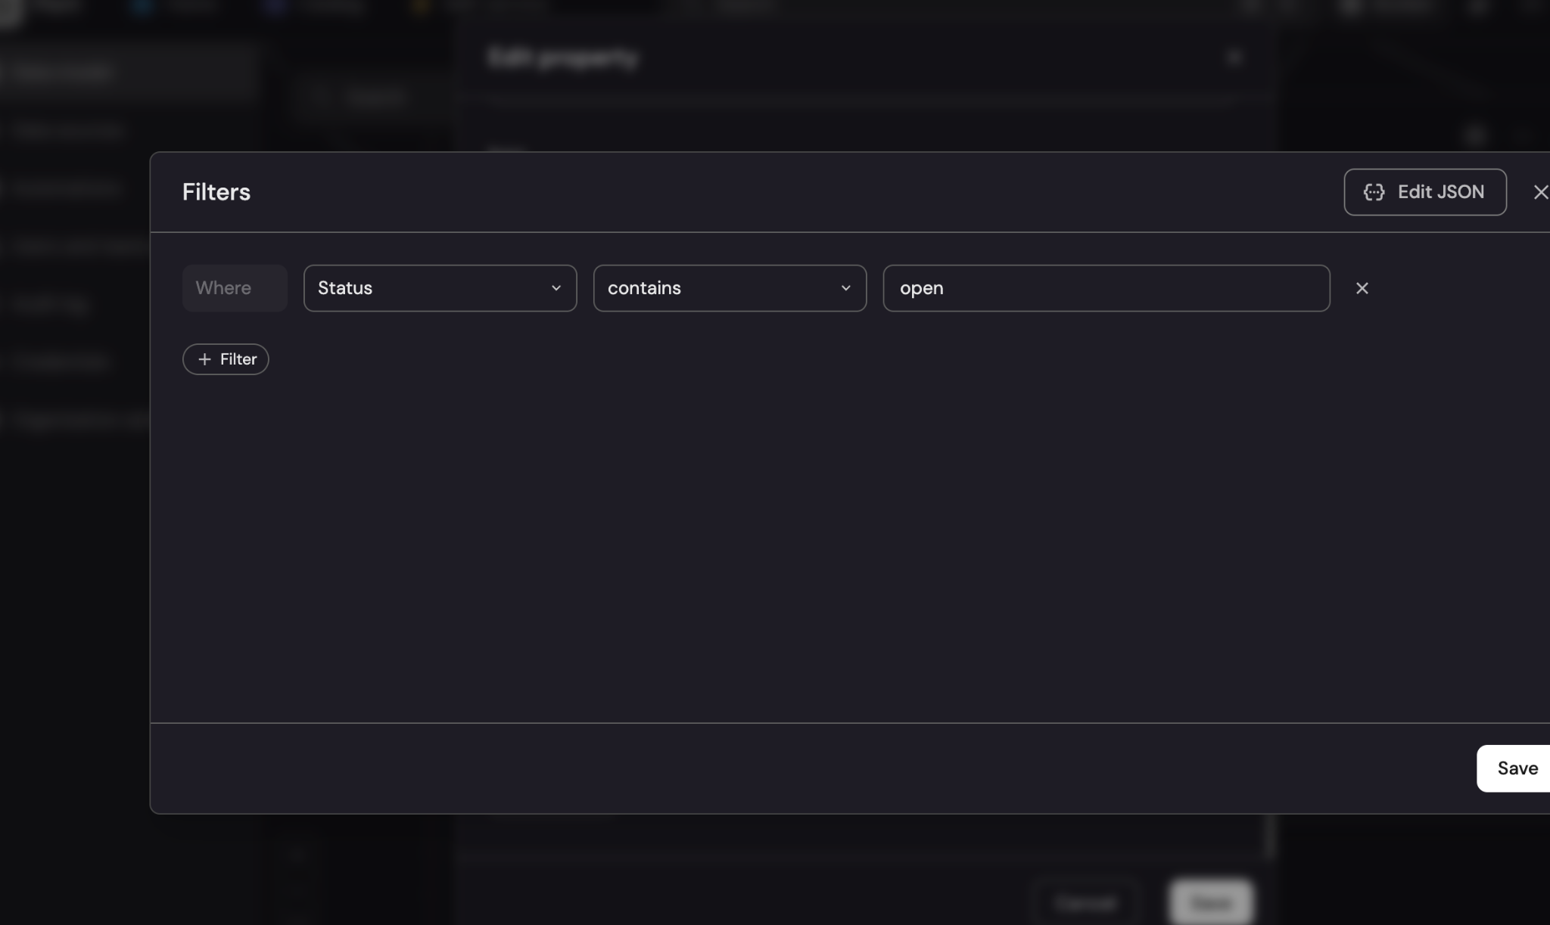

1. **Property Configuration Details**
   * **Aggregation Target:** pullRequest blueprint (automatically created by GitHub integration)
   * **Aggregation Function:** count to tally matching pull requests
   * **Filter Condition:** status = "open" to include only active pull requests
   * **Data Type:** number for numeric calculations and comparisons

#### Verification Process

* **Property Display:** Confirmed the property appeared in Repository entity views
* **Count Accuracy:** Cross-referenced displayed counts with actual GitHub PR numbers
* **Real-time Updates:** Verified counts updated automatically when PR status changed

### 

### 

### 

### Step 2: Scorecard Logic Implementation

#### Actions Performed

1. **Scorecard Creation**
   * Accessed Port → Scorecards → Create New Scorecard
   * Configured scorecard with the following specifications:

{

"identifier": "repository-pr-health",

"title": "Repository PR Health Assessment",

"blueprint": "repository",

"rules": [

{

"identifier": "open-pr-gold",

"title": "Gold Standard (< 5 PRs)",

"level": "Gold",

"query": {

"property": "openPullRequestsCount",

"operator": "<",

"value": 5

}

},

{

"identifier": "open-pr-silver",

"title": "Silver Standard (< 10 PRs)",

"level": "Silver",

"query": {

"property": "openPullRequestsCount",

"operator": "<",

"value": 10

}

},

{

"identifier": "open-pr-bronze",

"title": "Bronze Standard (< 15 PRs)",

"level": "Bronze",

"query": {

"property": "openPullRequestsCount",

"operator": "<",

"value": 15

}

}

]

}

1. **Threshold Logic Explanation**
   * **Gold (< 5 PRs):** Indicates excellent PR management with minimal backlog
   * **Silver (< 10 PRs):** Shows good PR management with manageable queue
   * **Bronze (< 15 PRs):** Acceptable but suggests potential bottlenecks
   * **Below Bronze (≥ 15 PRs):** Indicates PR management issues requiring attention

#### Verification Process

* **Automated Classification:** Confirmed repositories automatically received appropriate tier classifications
* **Threshold Testing:** Verified classification changes when PR counts crossed defined thresholds
* **Multi-Repository Testing:** Validated scorecard functionality across repositories with varying PR counts

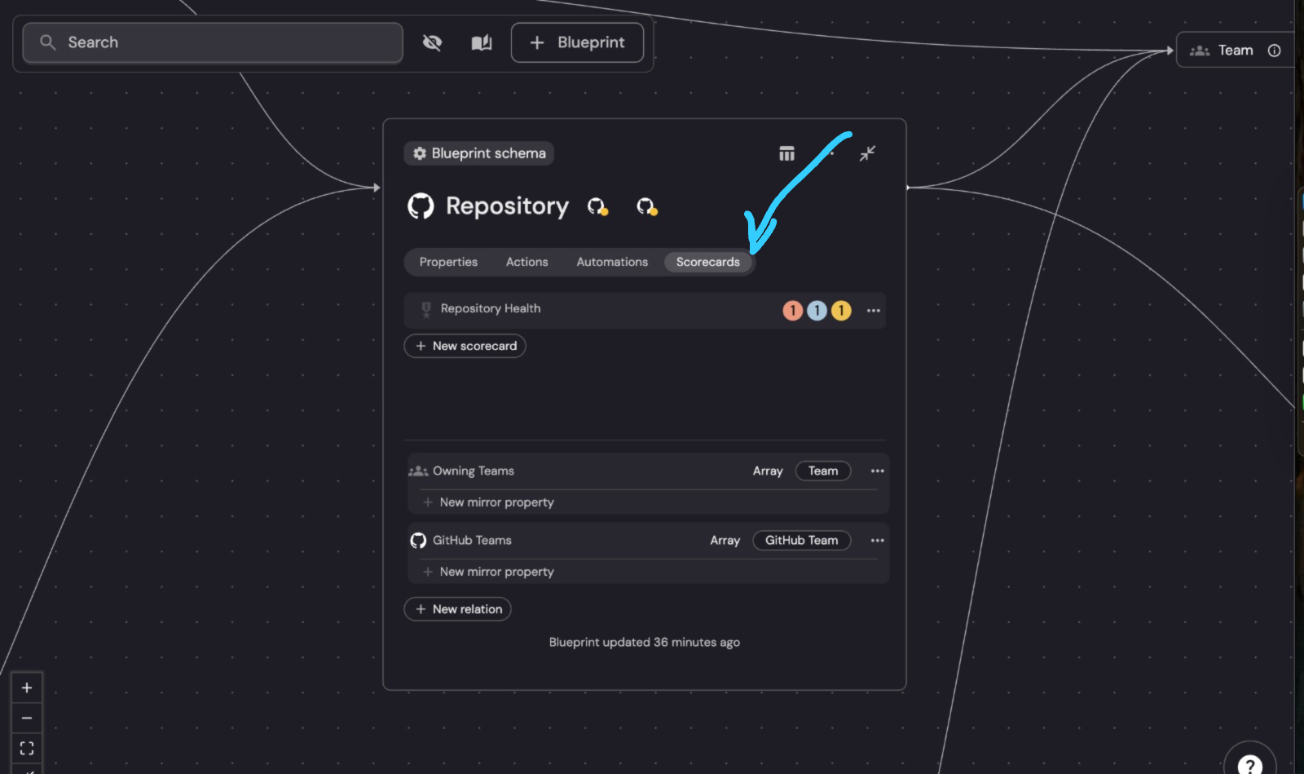

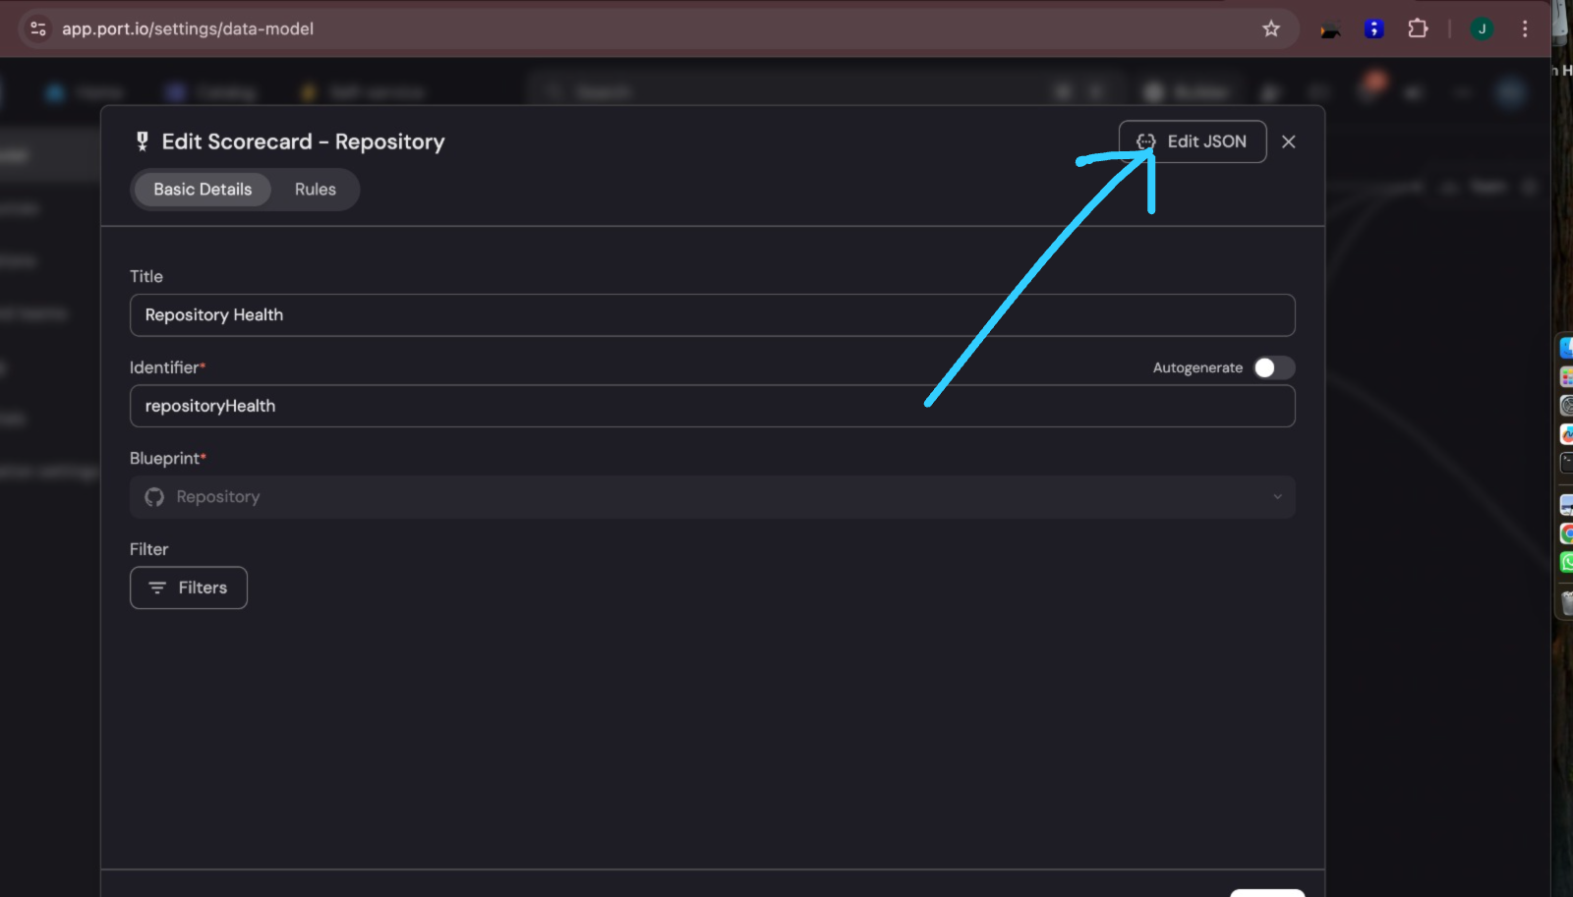

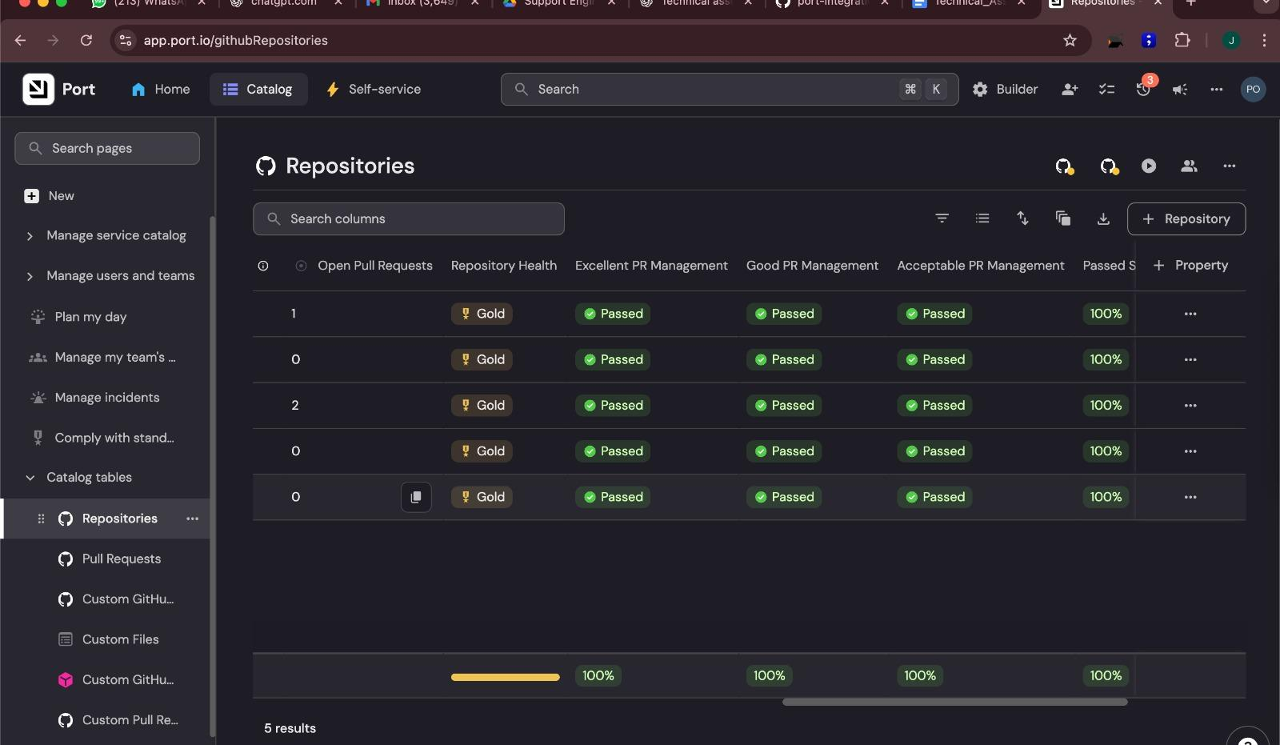

## Question 4: GitHub Workflow Troubleshooting Guide

### Problem Statement Analysis

A customer reports that their self-service action in Port remains in "IN PROGRESS" status indefinitely when attempting to trigger a GitHub workflow. This indicates a breakdown in the communication chain between Port and GitHub Actions.

### Systematic Troubleshooting Approach

#### Phase 1: GitHub App Installation and Permissions Verification

##### **1.1 Verify GitHub App Installation**

**Problem:** Port cannot trigger workflows if the GitHub App is not properly installed.

**Diagnostic Steps:**

# Check installed GitHub Apps for organization

curl -H "Authorization: token <GITHUB_PAT>" \

-H "Accept: application/vnd.github.v3+json" \

https://api.github.com/orgs/<ORG_NAME>/installations

# Check repository access

curl -H "Authorization: token <GITHUB_PAT>" \

-H "Accept: application/vnd.github.v3+json" \

https://api.github.com/repos/<ORG>/<REPO>/installation

**Expected Results:**

* Port GitHub App appears in organization installations
* Target repository shows active installation ID
* Installation status is "active"

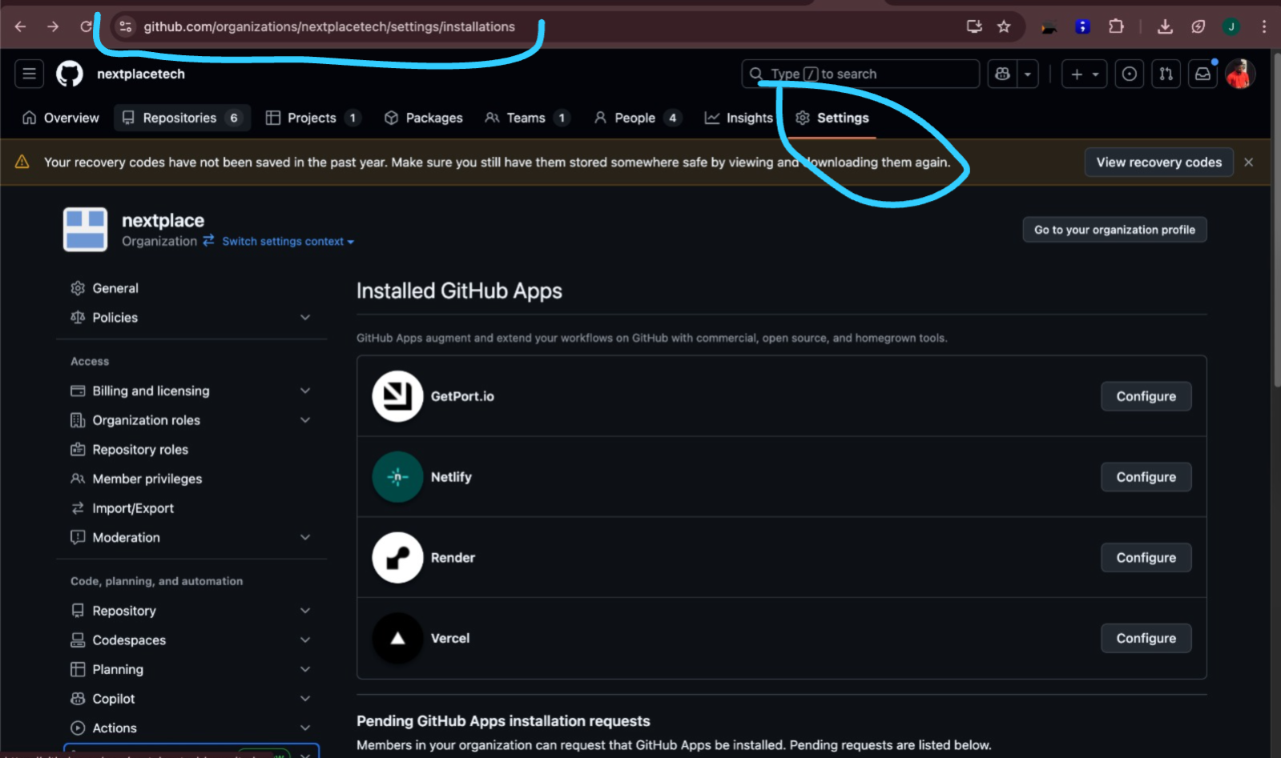

**Resolution Actions:**

* Reinstall Port GitHub App from GitHub Marketplace
* Grant access to specific target repositories
* Verify organization-level permissions if applicable

##### **1.2 Validate Required Permissions**

**Problem:** Insufficient permissions prevent workflow triggering.

**Required Permissions:**

* **Actions: Read and Write** - Essential for workflow triggering
* **Contents: Read** - Required for workflow file access
* **Metadata: Read** - Needed for repository information
* **Pull Requests: Read/Write** - If workflow interacts with PRs

**Verification Method:**

# Check current permissions

curl -H "Authorization: token <GITHUB_PAT>" \

-H "Accept: application/vnd.github.v3+json" \

https://api.github.com/repos/<ORG>/<REPO>/installation

#### Phase 2: Workflow File Validation

##### **2.1 File Location and Naming**

**Problem:** GitHub cannot locate workflow files in incorrect locations.

**Critical Requirements:**

* **Location:** Must be in .github/workflows/ directory
* **Branch:** Must exist on repository's default branch (main/master)
* **Naming:** Exact filename match in Port configuration (including .yml/.yaml extension)

**Verification Commands:**

# Check workflow file exists

curl -H "Authorization: token <GITHUB_PAT>" \

-H "Accept: application/vnd.github.v3+json" \

https://api.github.com/repos/<ORG>/<REPO>/contents/.github/workflows

# Validate file content

curl -H "Authorization: token <GITHUB_PAT>" \

-H "Accept: application/vnd.github.v3+json" \

https://api.github.com/repos/<ORG>/<REPO>/contents/.github/workflows/<WORKFLOW_FILE>



##### **2.2 YAML Syntax Validation**

**Problem:** Invalid YAML prevents workflow recognition.

**Validation Tools:**

# Local YAML validation

yamllint .github/workflows/your-workflow.yml

#### Phase 3: Workflow Trigger Configuration

##### **3.1 Correct Trigger Type**

**Problem:** Port requires workflow_dispatch trigger type.

**Incorrect Configuration:**

# ❌ This will not work with Port

on:

push:

branches: [main]

pull_request:

branches: [main]

**Correct Configuration:**

# ✅ Port-compatible trigger

on:

workflow_dispatch:

inputs:

service_name:

required: true

type: string

description: 'Service name to deploy'

environment:

required: true

type: string

description: 'Target environment'

default: 'development'

##### **3.2 Input Parameter Mapping**

**Problem:** Mismatched inputs between Port action and GitHub workflow.

**Port Action Configuration:**

{

"identifier": "deploy-service",

"title": "Deploy Service",

"trigger": {

"type": "self-service",

"operation": "CREATE",

"userInputs": {

"properties": {

"service_name": {

"type": "string",

"title": "Service Name"

},

"environment": {

"type": "string",

"title": "Environment",

"enum": ["development", "staging", "production"]

}

}

}

},

"invocationMethod": {

"type": "GITHUB",

"org": "your-org",

"repo": "your-repo",

"workflow": "deploy.yml",

"workflowInputs": {

"service_name": "{{ .inputs.service_name }}",

"environment": "{{ .inputs.environment }}"

}

}

}

#### Phase 4: Authentication and Secrets Validation

##### **4.1 Port Authentication Secrets**

**Problem:** Missing or incorrect Port credentials prevent status updates.

**Required GitHub Repository Secrets:**

# In GitHub: Settings → Secrets and variables → Actions

PORT_CLIENT_ID=<client-id-from-port>

PORT_CLIENT_SECRET=<client-secret-from-port>

**Credential Location in Port:**

* Navigate to Settings → Credentials
* Copy Client ID and Client Secret values
* Ensure secrets are added to correct repository

#### Phase 5: Direct API Testing

##### **5.1 Manual Workflow Trigger**

**Purpose:** Isolate whether issue is with Port or GitHub.

**API Test Command:**

curl -X POST \

-H "Authorization: token <GITHUB_PAT>" \

-H "Accept: application/vnd.github.v3+json" \

https://api.github.com/repos/<ORG>/<REPO>/actions/workflows/<WORKFLOW_FILE>/dispatches \

-d '{

"ref": "main",

"inputs": {

"service_name": "test-service",

"environment": "development"

}

}'

**Result Analysis:**

* **Success (HTTP 204):** GitHub workflow system is healthy; issue is in Port configuration
* **Failure (HTTP 4xx/5xx):** GitHub-side configuration problem

##### 

##### 

##### 

##### 

##### 

##### **5.2 Port Action Configuration Validation**

**If API test succeeds, verify Port configuration:**

{

"invocationMethod": {

"type": "GITHUB",

"org": "exact-github-org-name",

"repo": "exact-repository-name",

"workflow": "exact-workflow-filename.yml",

"workflowInputs": {

"input_name": "{{ .inputs.input_name }}"

}

}

}

**Common Mistakes:**

* Incorrect organization/repository names (case-sensitive)
* Wrong workflow filename or extension
* Missing workflowInputs mapping
* Typos in input parameter names

#### Phase 6: Monitoring and Debugging

##### **6.1 GitHub Actions Log Analysis**

**Location:** Repository → Actions tab → Workflow runs

**Key Information to Check:**

* Workflow run appearance (indicates successful triggering)
* Input parameter values received
* Execution steps and failure points
* Error messages and stack traces

##### **6.2 Debug Logging Implementation**

**Add to workflow for detailed diagnostics:**

- name: Debug Workflow Inputs

run: |

echo "=== Workflow Debug Information ==="

echo "Event Name: ${{ github.event_name }}"

echo "Event Action: ${{ github.event.action }}"

echo "Ref: ${{ github.ref }}"

echo "Actor: ${{ github.actor }}"

echo "=== Input Parameters ==="

echo "All Inputs: ${{ toJson(github.event.inputs) }}"

echo "Service Name: ${{ github.event.inputs.service_name }}"

echo "Environment: ${{ github.event.inputs.environment }}"

echo "=== Environment Variables ==="

env | grep -E "(PORT_|GITHUB_)" | sort

##### **6.3 Port Action Status Monitoring**

**Port Dashboard Monitoring:**

* Check action execution logs in Port
* Verify action status transitions
* Review any error messages or timeout indicators

### Systematic Troubleshooting Checklist

#### Immediate Actions (5 minutes)

* [ ] Verify GitHub App installation status
* [ ] Check workflow file exists in .github/workflows/
* [ ] Confirm workflow has workflow_dispatch trigger
* [ ] Validate Port action configuration naming (org/repo/workflow)

#### Detailed Validation (15 minutes)

* [ ] Test manual workflow trigger via GitHub API
* [ ] Verify all required GitHub repository secrets exist
* [ ] Check GitHub Actions tab for workflow execution attempts
* [ ] Review Port action logs for error messages

#### Advanced Debugging (30 minutes)

* [ ] Add debug logging to workflow
* [ ] Validate input parameter mapping between Port and GitHub
* [ ] Test with minimal workflow configuration
* [ ] Review GitHub webhook delivery logs (if applicable)

### Common Resolution Patterns

#### Pattern 1: Permission Issues

**Symptoms:** API returns 403/404 errors **Resolution:** Reinstall GitHub App with correct permissions

#### Pattern 2: Configuration Mismatch

**Symptoms:** Workflow not found errors **Resolution:** Verify exact naming in Port configuration

#### Pattern 3: Input Mapping Problems

**Symptoms:** Workflow starts but receives empty/incorrect inputs **Resolution:** Update workflowInputs mapping in Port action

#### Pattern 4: Authentication Failures

**Symptoms:** Port action starts but cannot update status **Resolution:** Add/update PORT_CLIENT_ID and PORT_CLIENT_SECRET

### Prevention Best Practices

1. **Test Workflow Independently:** Always test workflows manually before connecting to Port
2. **Use Descriptive Names:** Avoid special characters in workflow and action names
3. **Implement Comprehensive Logging:** Add debug outputs for troubleshooting
4. **Monitor Regularly:** Set up alerts for failed action executions
5. **Document Dependencies:** Maintain clear documentation of required secrets and permissions